Setting Up Picture Login

- Power on the Chromebook.
- Click Next.
- Enter your District username and click “Go”
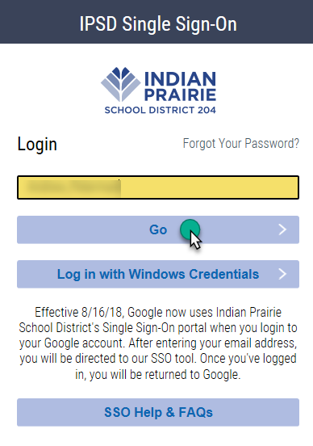
- Select 4 pictures that will be used to login to the SSO on future logins.
(Note: If a student does not find a preferred picture, click the recycle button and 9 new images will load.)
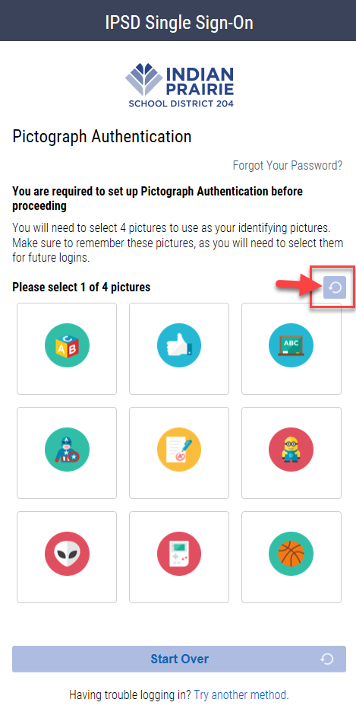
- After selecting four (4) pictures, enter your District password and click “Go”.
(Note: Any picture can be changed by clicking and selecting a new image.)
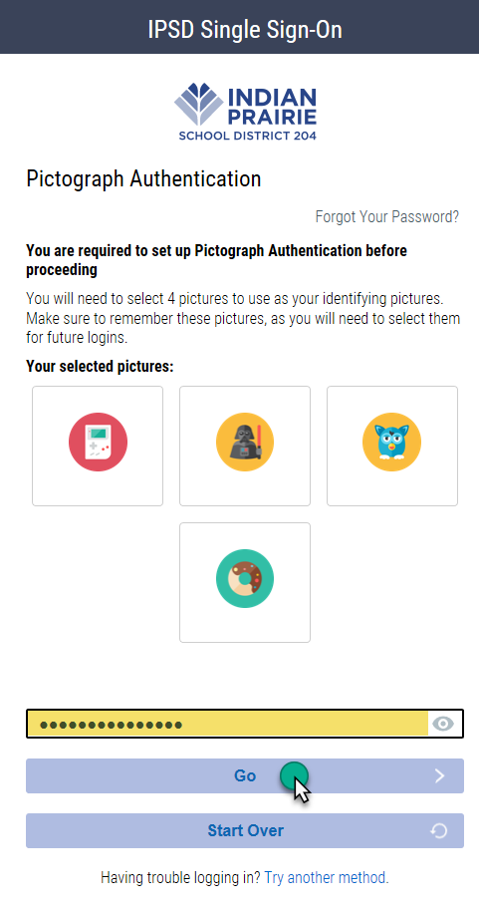
5. Future logins to the Chromebook/SSO will use the District username and the four
(4) pictures without needing to type the password.

**Please note, the picture login will only work on Chromebooks and the SSO. If students use a Windows PC they will need to use their District username and District password to login into the PC.

